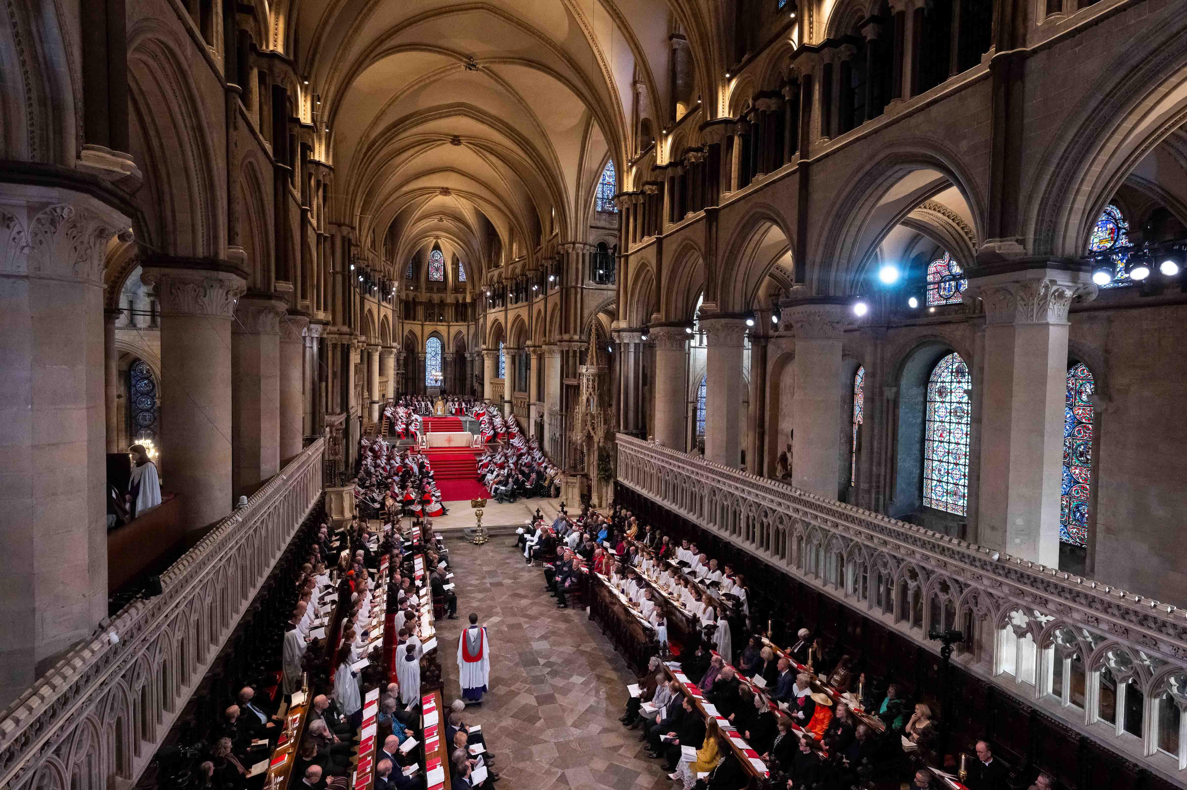
Photo courtesy of Lambeth Palace, © Andrew Baker

d&b solutions deploys Sennheiser Spectera for the installation of the Archbishop of Canterbury
Wideband system delivers flawless wireless audio in landmark BBC broadcast

Marlow, UK, June 2026 – On 25 March 2026, Canterbury Cathedral hosted one of the most significant moments in the Church of England’s 1,400-year history: the installation of Sarah Mullally as the 106th Archbishop of Canterbury, the first woman ever to hold the office. Seated in the Chair of St. Augustine before some 2,000 guests, among them Prince William and the Princess of Wales, alongside representatives from the Commonwealth, the United Nations and global church leaders, the ceremony demanded audio infrastructure of the highest order, especially as it was broadcast live by the BBC to an audience of millions. d&b solutions deployed Sennheiser’s Spectera wideband wireless system across the full 160-metre length of the Cathedral, with 42 beltpacks running across two base stations, ensuring clear and reliable transmission throughout.

George Veys, Project Manager at d&b solutions, was among the first in the industry to recognise Spectera’s potential, placing d&b solutions’ order at the product’s IBC 2024 unveiling event. He explains what drove that early investment: “Our original appetite came from wanting to invest in a state-of-the-art technology that offers us both rental stock flexibility in an ever crowded RF spectrum, but also a highly versatile product able to operate as both an IEM receiver, mic transmitter, or both.” Since then, d&b solutions has deployed Spectera across a growing number of projects, with Canterbury Cathedral representing their most ambitious use of the system to date.

d&b solutions has a longstanding relationship with the Church of England and Lambeth Palace, and was drawn into the project early. What began as a modest live stream quickly grew into a full BBC broadcast, with the brief expanding accordingly: more microphones, greater resilience, and a robust feed path direct to the outside broadcast unit.

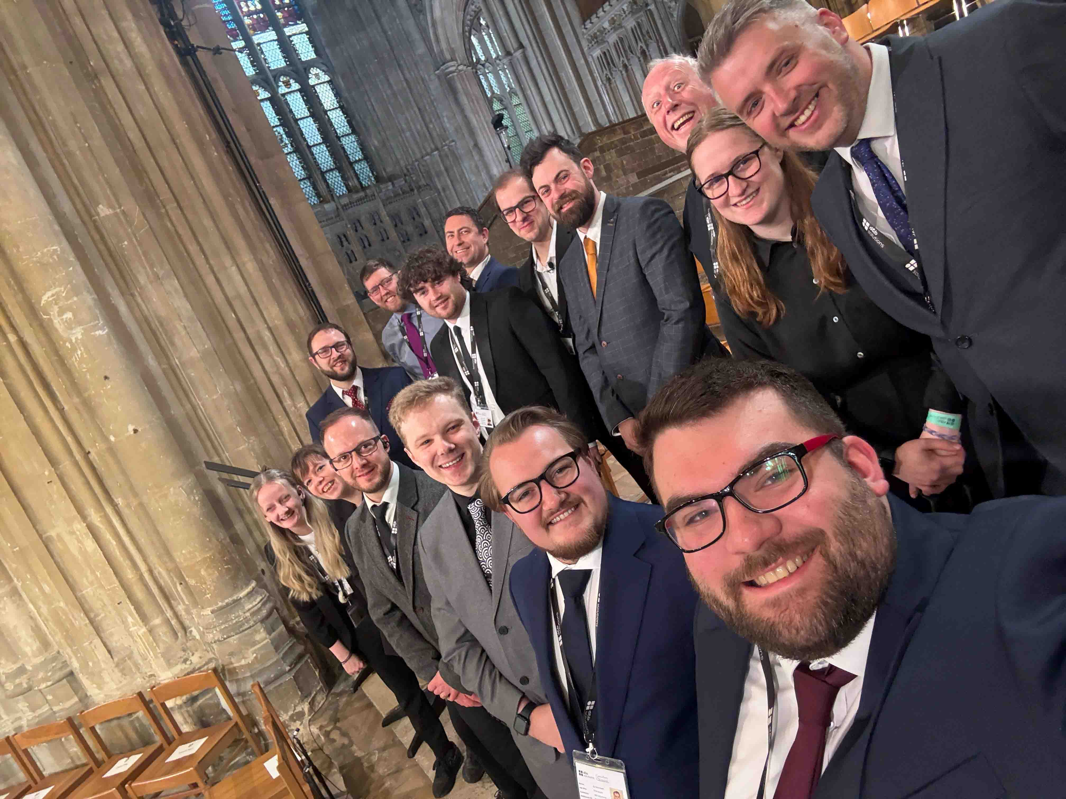
The d&b solutions crew: Left to right, front: Carys Walker, El Ashwood, Craig Lawrence, James Morris, Matt Wadley, Eli Branham; rear: Dave Scarlett, Aaron Shearer, Ian Reeves, Joe Lock, Josh Bobby, Vince Blake, Mark Isbister, Naomi Schofield, Mitch Jones (Photo courtesy of d&b solutions)

Dave Scarlett, Head of Audio (Live) at d&b solutions, explains: “Fairly early on, we identified the high likelihood that significant amounts of the Cathedral floor space would be used during the service, with processions and parts of the ceremony taking place in different areas of the building.” The Cathedral is, as he puts it, “deceptively big when you first step inside, and then it keeps going and it keeps going”, with some antenna cable runs exceeding 100 metres. Conventional approaches would have meant complex RF-over-fibre systems with combiners and difficult cabling. For long cable runs, the CAT5 cables of Spectera’s DAD antennas can easily be combined with fibre, using media converters with POE injection – a much simpler and cleaner solution.

As some antenna cable runs exceeded 100 metres, d&b solutions combined the CAT5 cables of Spectera’s DAD antennas with fibre, using media converters with POE injection (Photo courtesy of d&b solutions)

Mitch Jones, Production Account Manager – Live Events at d&b solutions, sums up the turning point: “It was meant to just be a live stream, but then it grew into a broadcast, so we knew we needed to upgrade the RF to Spectera. The Archbishop walks in at one end and is installed at the other, so we needed to pick her up consistently the whole way. There was no other solution.”

The final system comprised two Spectera Base Stations, eight DAD antennas and 42 beltpacks, all running in mic mode. The supporting infrastructure comprised Allen & Heath mixing consoles, Yamaha I/O and conversion, and Netgear switching. There were no IEMs on the event at all: a mic-only setup that is, as Scarlett notes, highly unusual for a production of this size. For the Archbishop herself, two beltpacks and two lavalier microphones were deployed, one pack per Base Station, delivering effective redundancy for the most critical source on the broadcast. All microphone elements were DPA, including the near-invisible headsets of the 16-piece African choir.

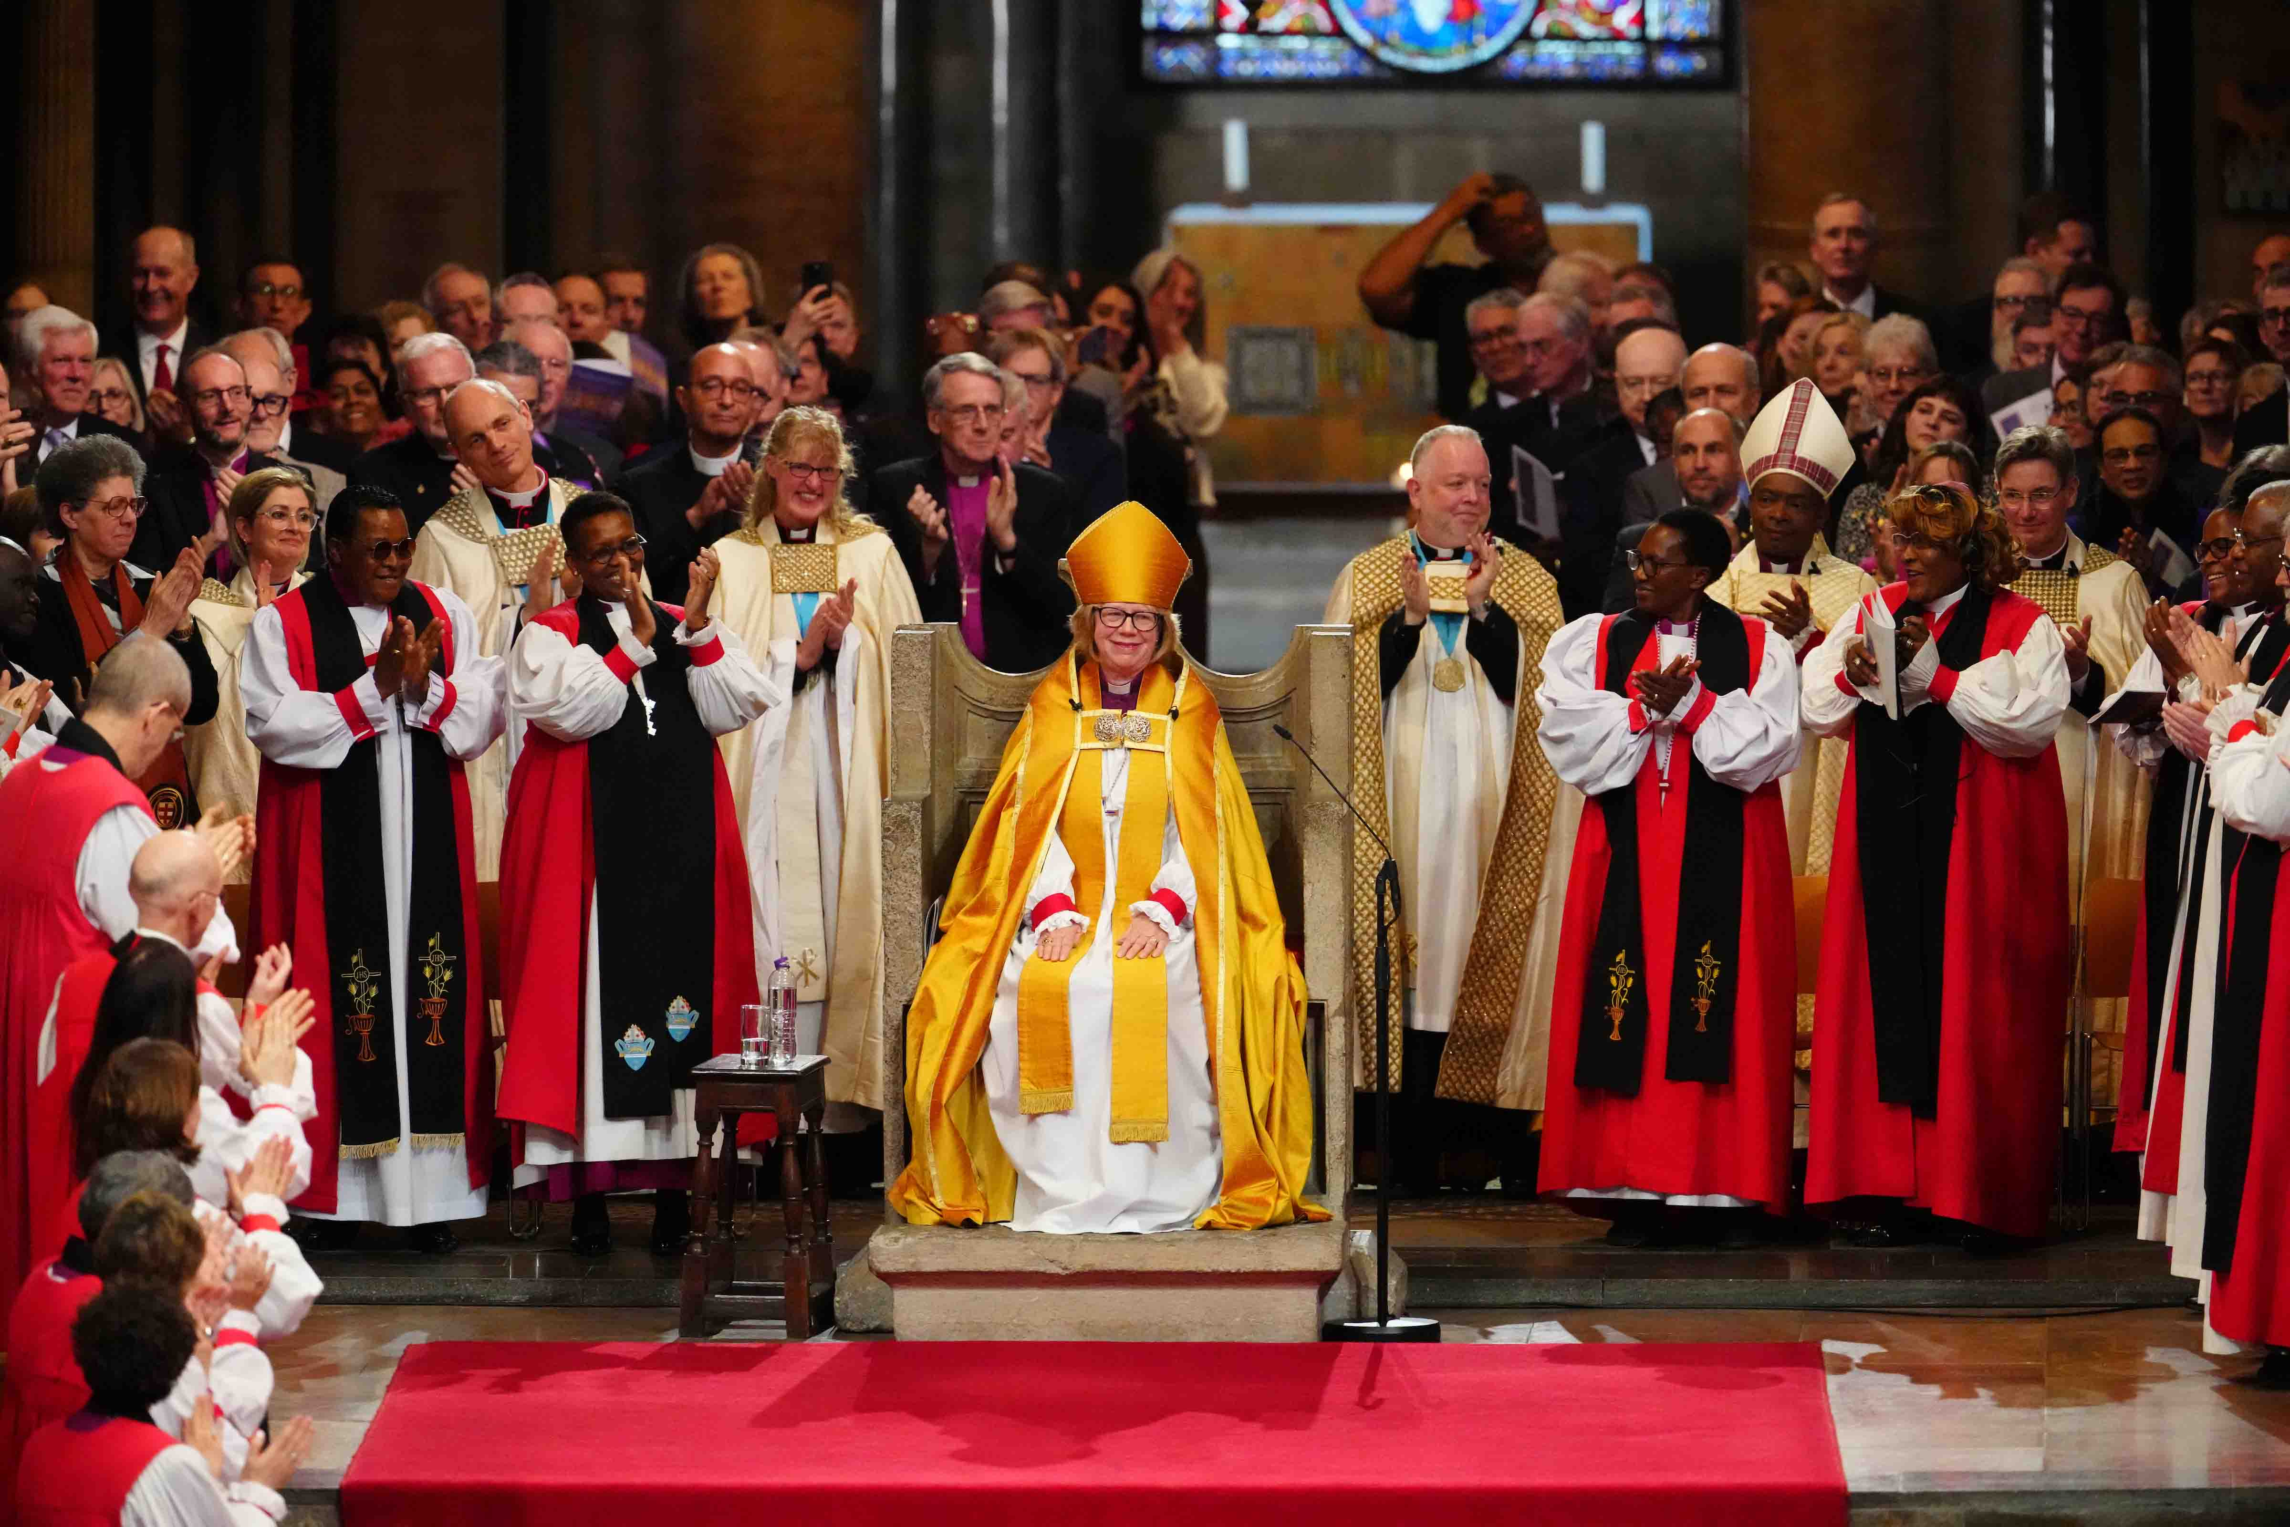
For the Archbishop, two beltpacks and two lavalier microphones were deployed, one pack per Base Station, delivering effective redundancy for the most critical source on the broadcast (Photo courtesy of Lambeth Palace, © Andrew Baker)

The Base Stations’ multiple output options proved equally valuable for the broadcast interface: While their Dante outputs fed d&b solutions’ wider PA network, the MADI outputs were sent directly to the OB truck, giving the BBC a very resilient audio path alongside the digital split provided by d&b solutions. With every seat in the Cathedral at a premium, Spectera’s compact footprint also made a material difference: a narrowband 42-channel system would have required rack space the venue simply could not spare.

With Spectera, mobile terminal control happens in the main RF carrier, no separate antenna infrastructure for control data is needed (Photo courtesy of d&b solutions)

With dignitaries arriving from around the world, d&b solutions knew that not every microphone would be rehearsed on its intended wearer before the cameras rolled. Remote control of pack parameters, particularly gain, during the live service was essential. In previous workflows this would have demanded a separate antenna infrastructure for control data; with Spectera, mobile terminal control happens in the main RF carrier, too, eliminating that overhead entirely.

The team also integrated Spectera with Sonoros, a UK-developed control and monitoring application, allowing mic engineers El Ashwood, Carys Walker and Ian Reeves to monitor system status and listen to individual feeds from anywhere on the Wi-Fi network via laptop or iPad; invaluable when miking up 42 people in a very short time.

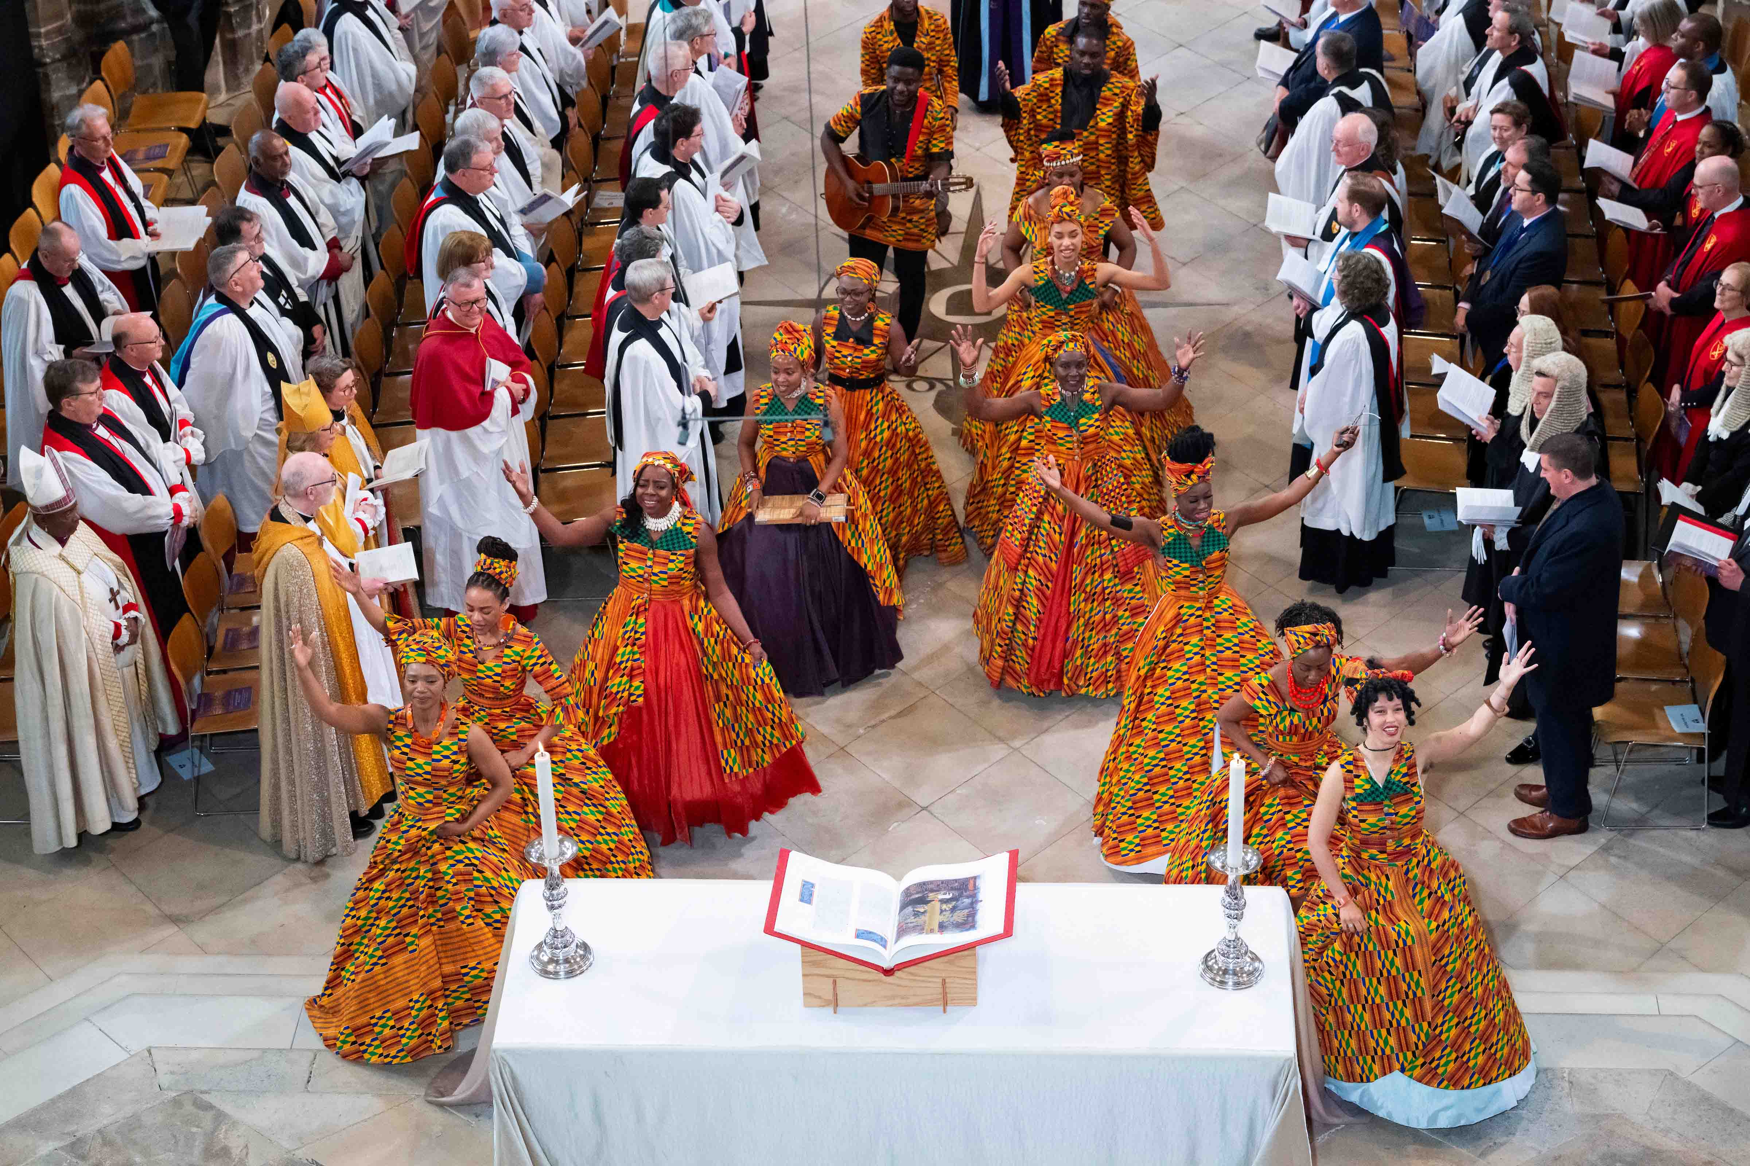
The African choir was miked up with Spectera beltpacks and DPA microphones (Photo courtesy of Lambeth Palace, © Andrew Baker)

This was d&b solutions’ most ambitious Spectera deployment to date and their first using antennas over fibre at this scale. Working closely with Sennheiser’s Kevin Gwyther-Brown and Technical Application Engineer Marcus Blight, the team received extensive remote support, including access to an unreleased firmware version that unlocked additional performance from the fibre infrastructure. Pre-production was also aided by the SoundBase Spectera Mode Planning tool, which allowed the team to map link modes and confirm system capacity before a single piece of kit was shipped.

For Mitch Jones, the manufacturer’s backing was itself part of the decision: “The confidence that Dave had in the system gave me the confidence that it was the right solution. When you’re covering that amount of beltpacks with limited space, a compact solution just makes sense, and everyone was really happy with what we put out.”

d&b solutions employed a total of 42 Spectera beltpacks

Load-in began the Thursday before the service, with the Cathedral remaining open to the public throughout. The BBC loaded in on Monday, rehearsals ran on Tuesday, and the live broadcast went out on Wednesday without incident. The OB crew, initially wary of a receiver with no XLR outputs, came away convinced. “After the show, they reflected that it had been a really excellent deployment and they had no reservations,” recalls Scarlett. “In an increasingly challenging RF environment, products like Spectera are a really sharp tool to have on the belt.”

For Veys, the Canterbury project was exactly the validation the team had envisioned: “We chose Spectera for this project because of its market leading RF performance and, due to the size of the Cathedral, the ability for the product to perform in multiple RF zones seamlessly. This is exactly the kind of project we envisioned Spectera would be perfect for, and it performed brilliantly.”

[Ends]

The high-resolution images accompanying this media release can be downloaded here.

About the Sennheiser brand
We live and breathe audio. We are driven by the passion to create audio solutions that make a difference. Building the future of audio and bringing remarkable sound experiences to our customers – this is what the Sennheiser brand has represented for more than 80 years. While professional audio solutions such as microphones, meeting solutions, streaming technologies and monitoring systems are part of the business of Sennheiser electronic SE & Co. KG, the business with consumer devices such as headphones, soundbars and speech-enhanced hearables is operated by Sonova Holding AG under the license of Sennheiser.
www.sennheiser.com
www.sennheiser-hearing.com

Global Press Contact
Maik Robbe
Maik.Robbe@sennheiser.com
+49 (5130) 600 – 1028

